LAB1 Sai Chaitanya Dasari 014337271



url : <http://13.52.238.134:3000/>

**1A) Analysis of Graphs:**

As per the results that I obtained from graph. I performed with and without in-built pooling system of database. Connection Pooling algorithm we use the pooling mechanism where this is done at the client end in gereral. In without pooling we just connect to the database and serve the request and close the connection once usage is done. However, in the pooling system we do the call_to_reset system which might increase the latency of the application

Connection pooling is thread safe.

2A) **Improve Sql Performance:**

1 **Query optimization**:

is one way where we do the indexing of the rows in the table.  
 2. Other way not using the distinct and (select *) from when retrieving the data.

3.The other ways is to use joins in the sql queries than using the nested queries

**3A)** Yes, The application that I developed is horizontally scalable. I used the jwt tokens to store the session variables. These give the developer the edge of scaling the application as per the requirements.

----------------------------------------------------------

The walk through of the application is done in 3 parts

1. the UI and flow
2. the backend S3, RDS & Deployment in EC2 instances
3. Testing’s (Jmeter and Mocha)

Results:

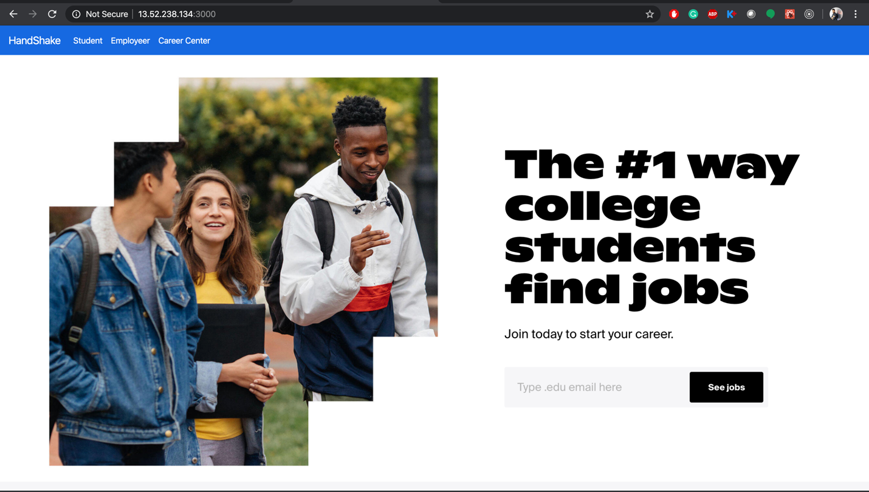

a)

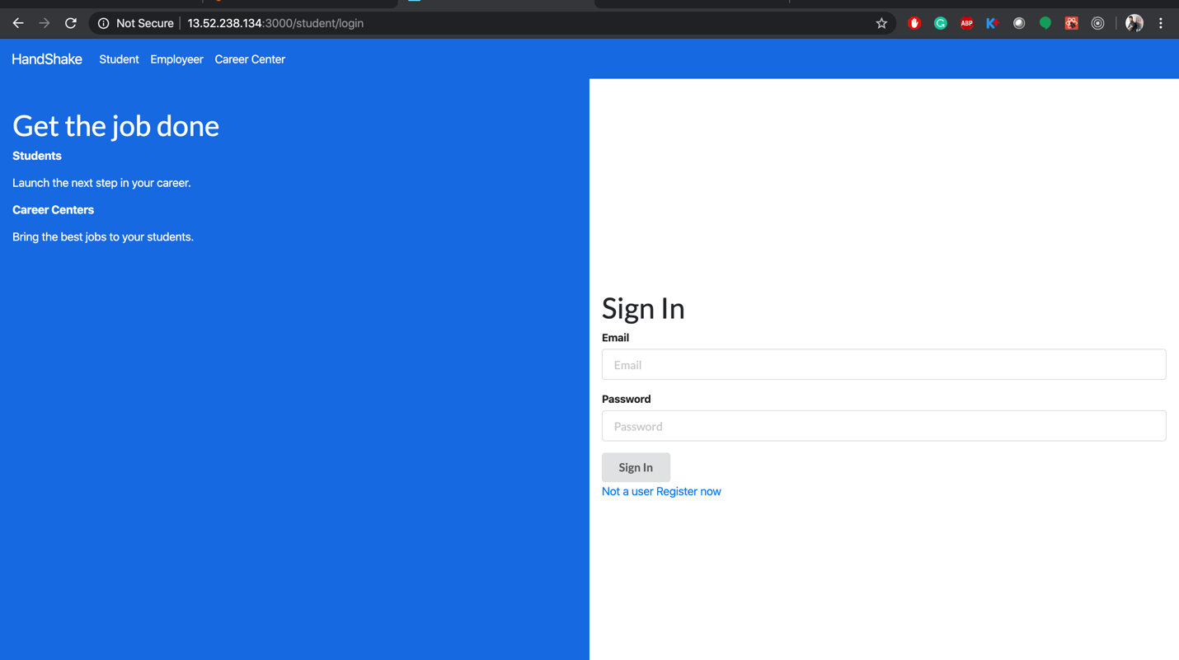

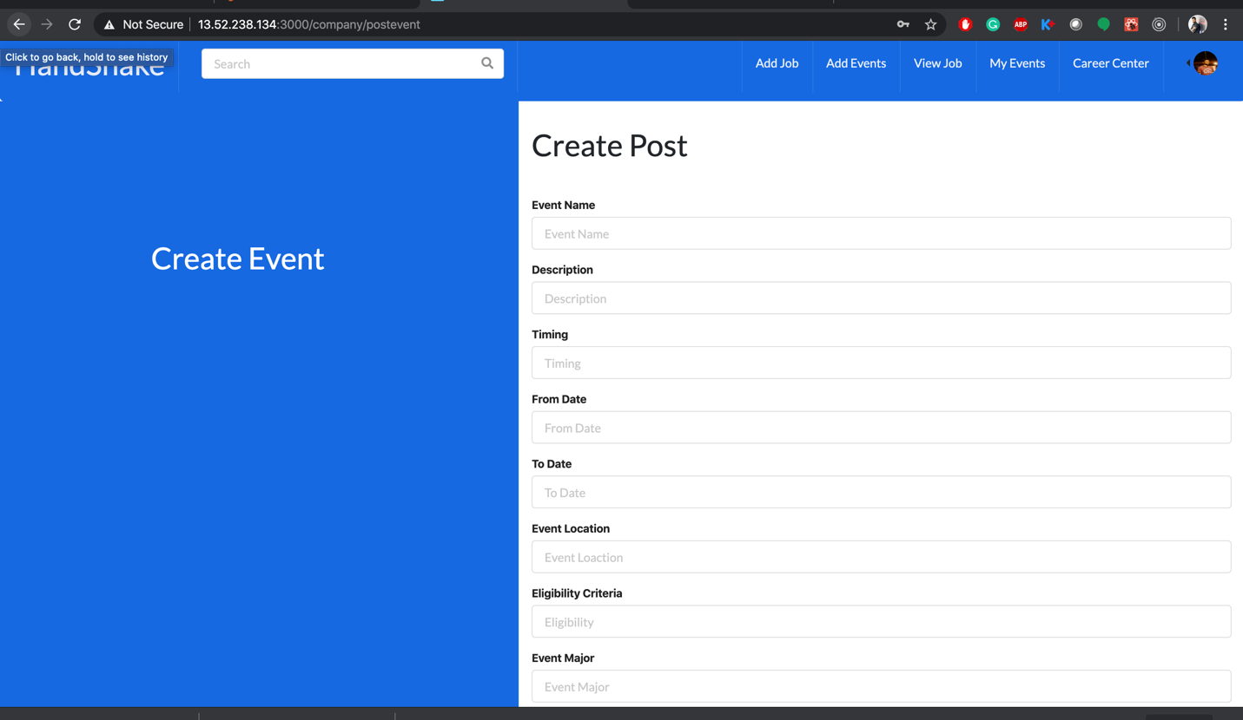

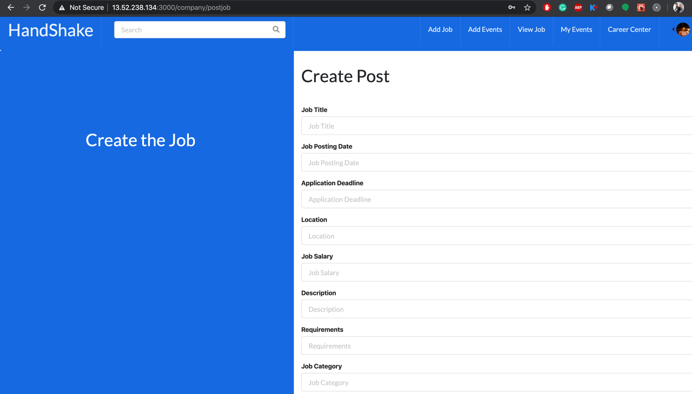

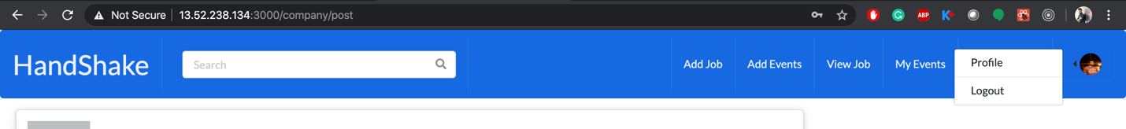

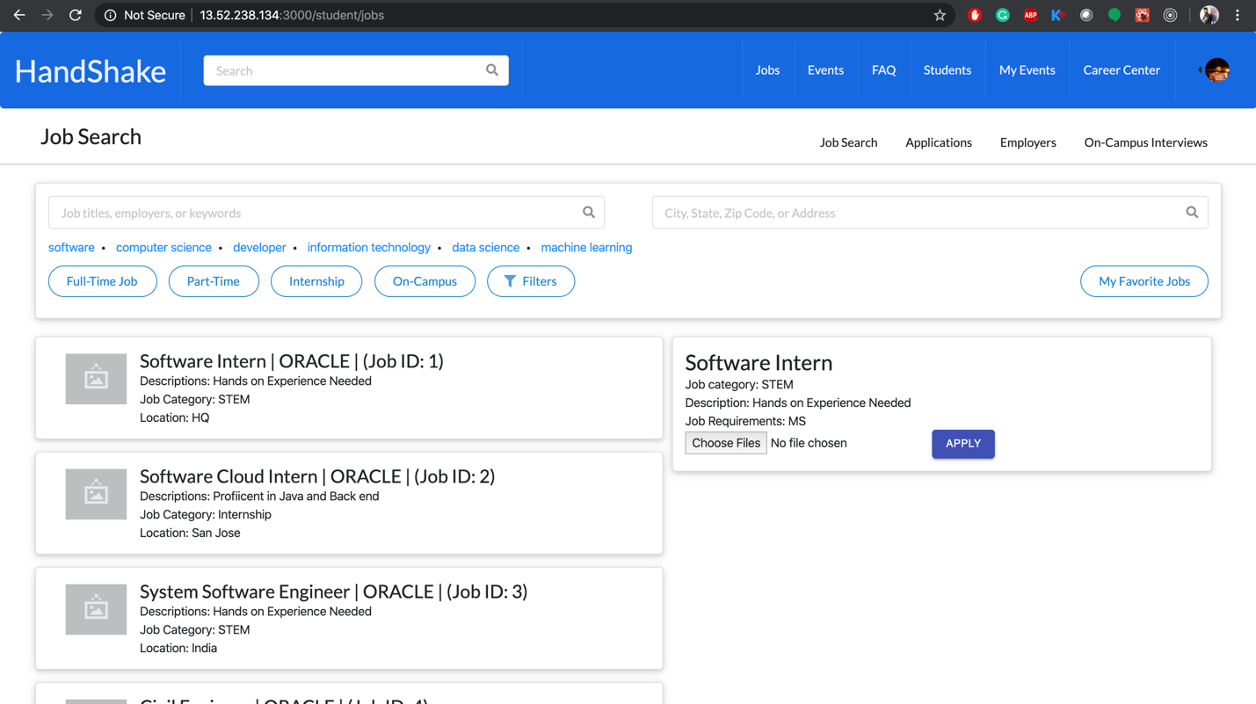

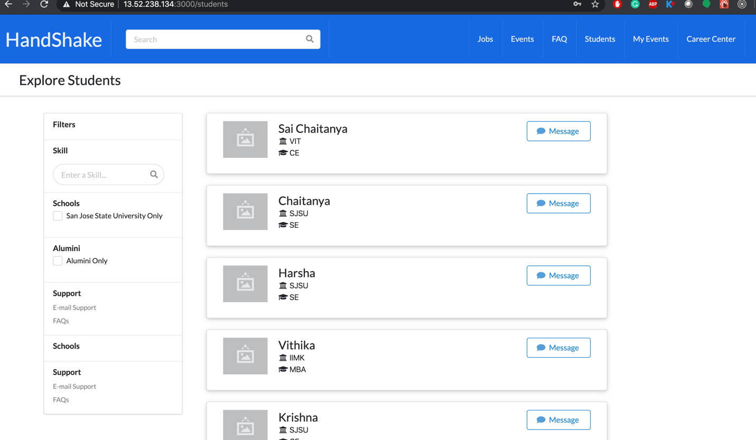

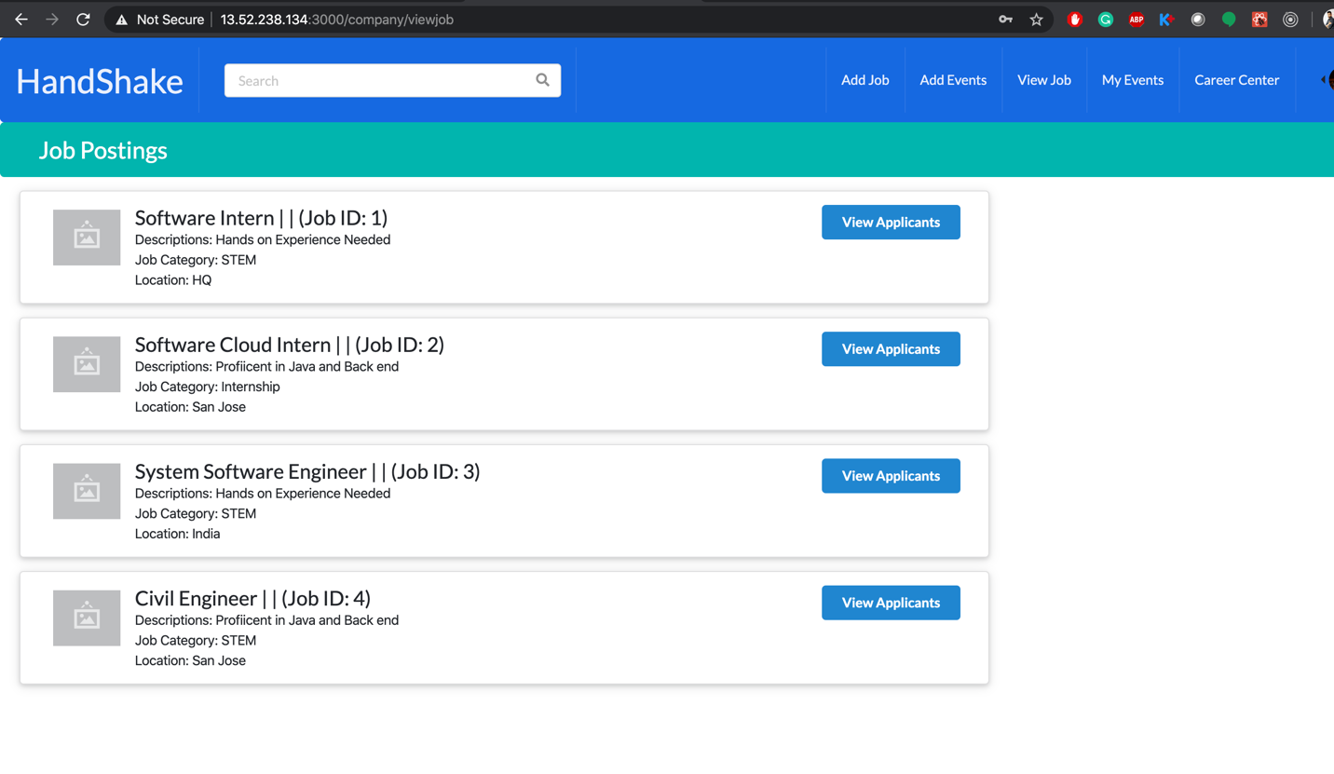

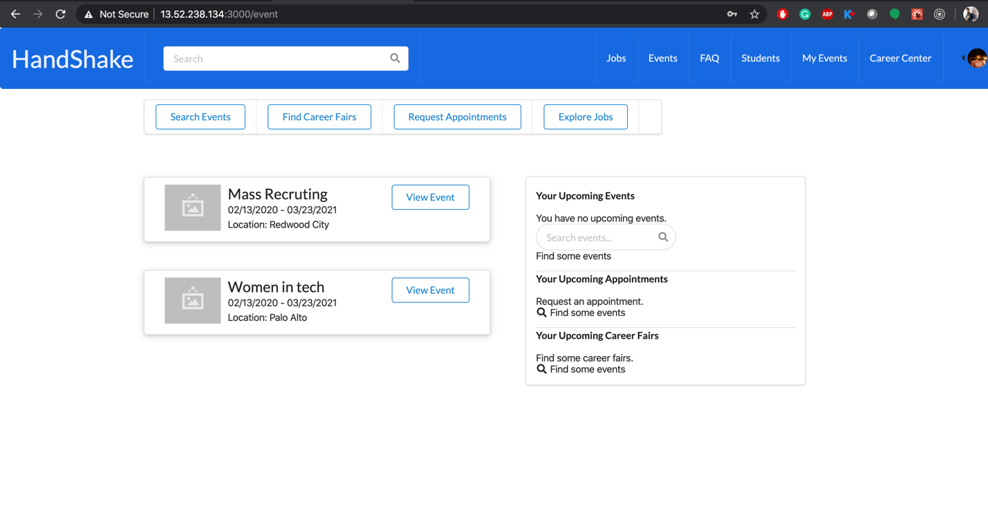



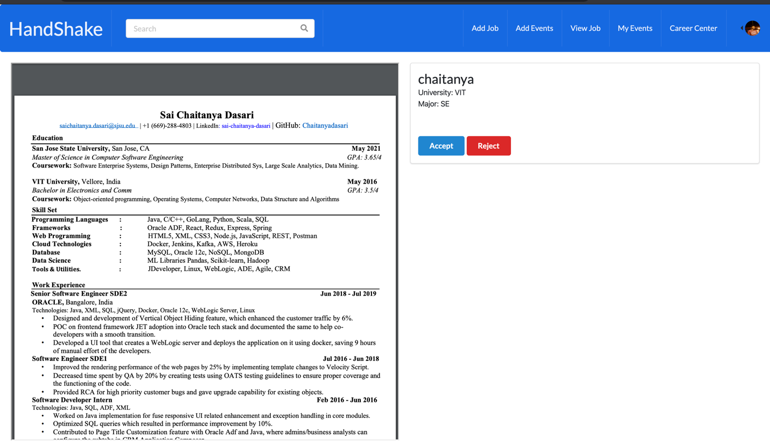

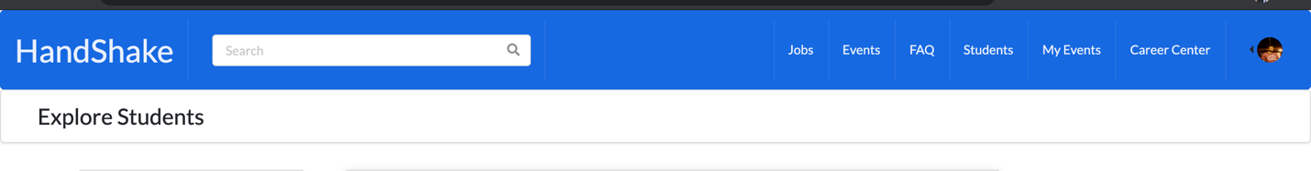

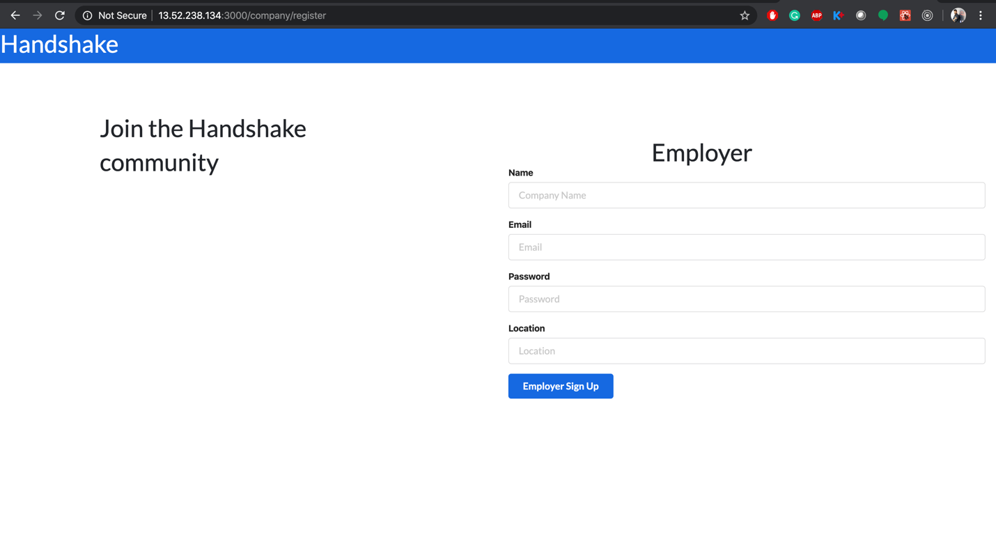

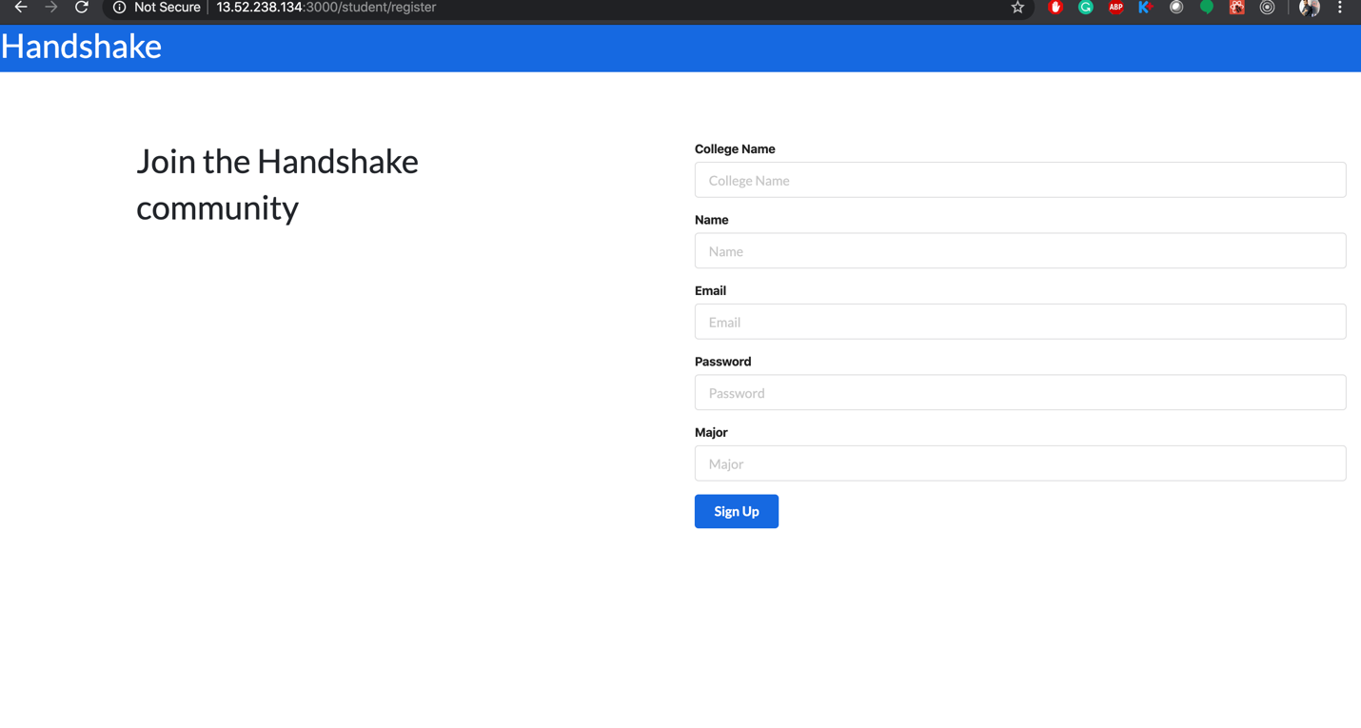

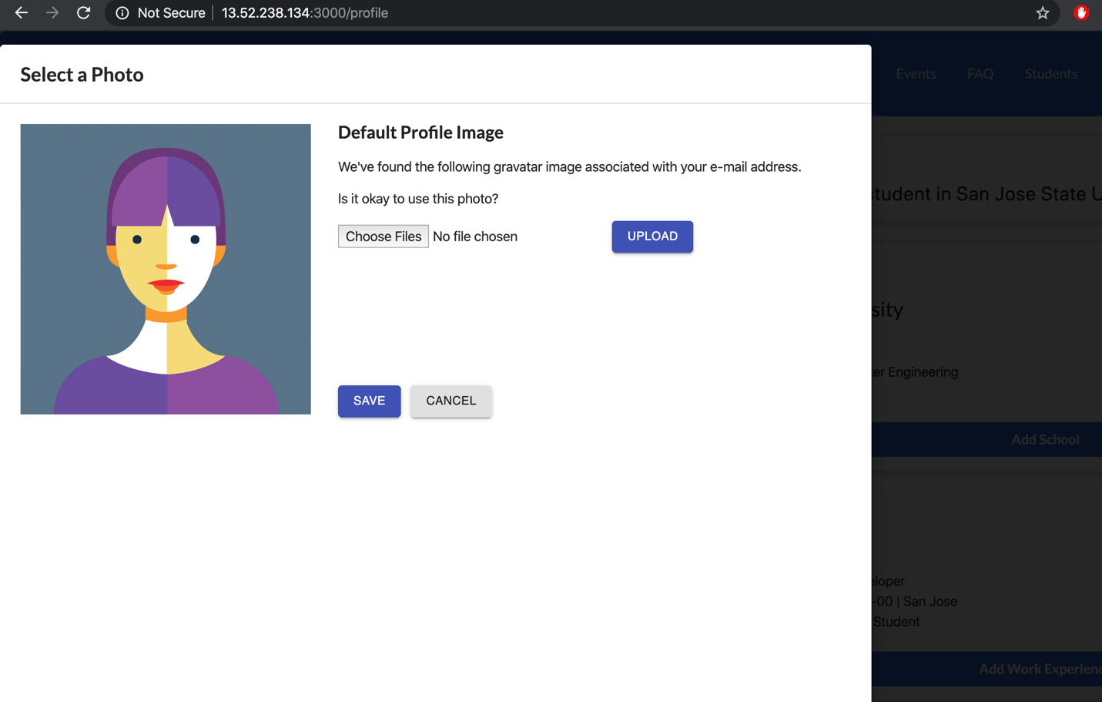

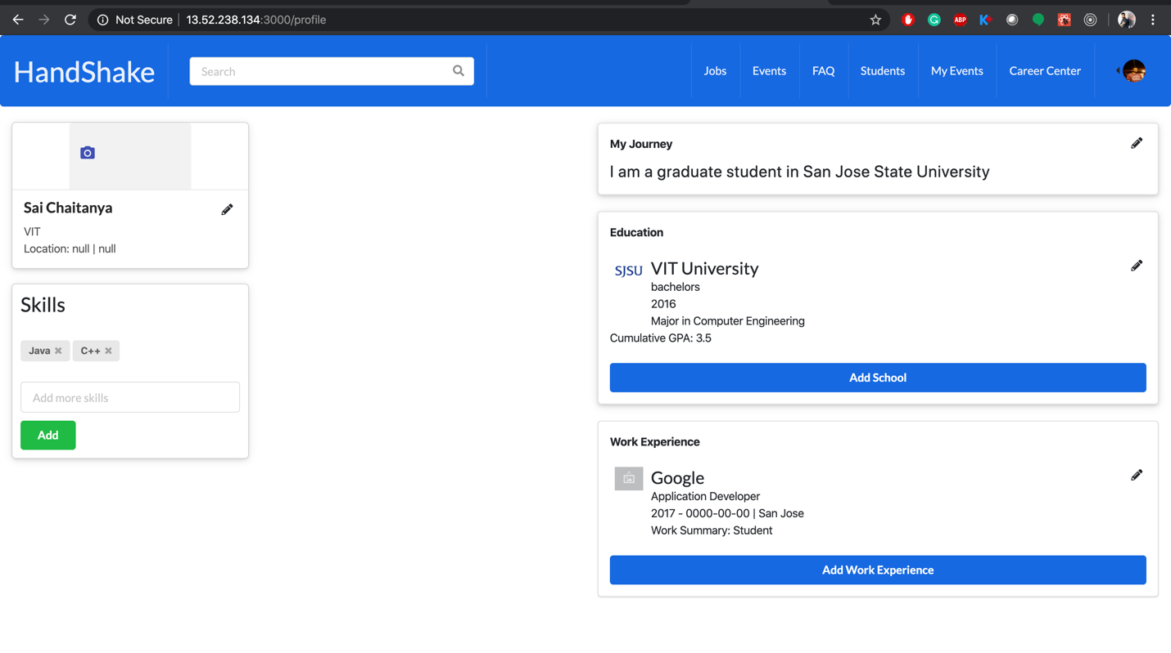

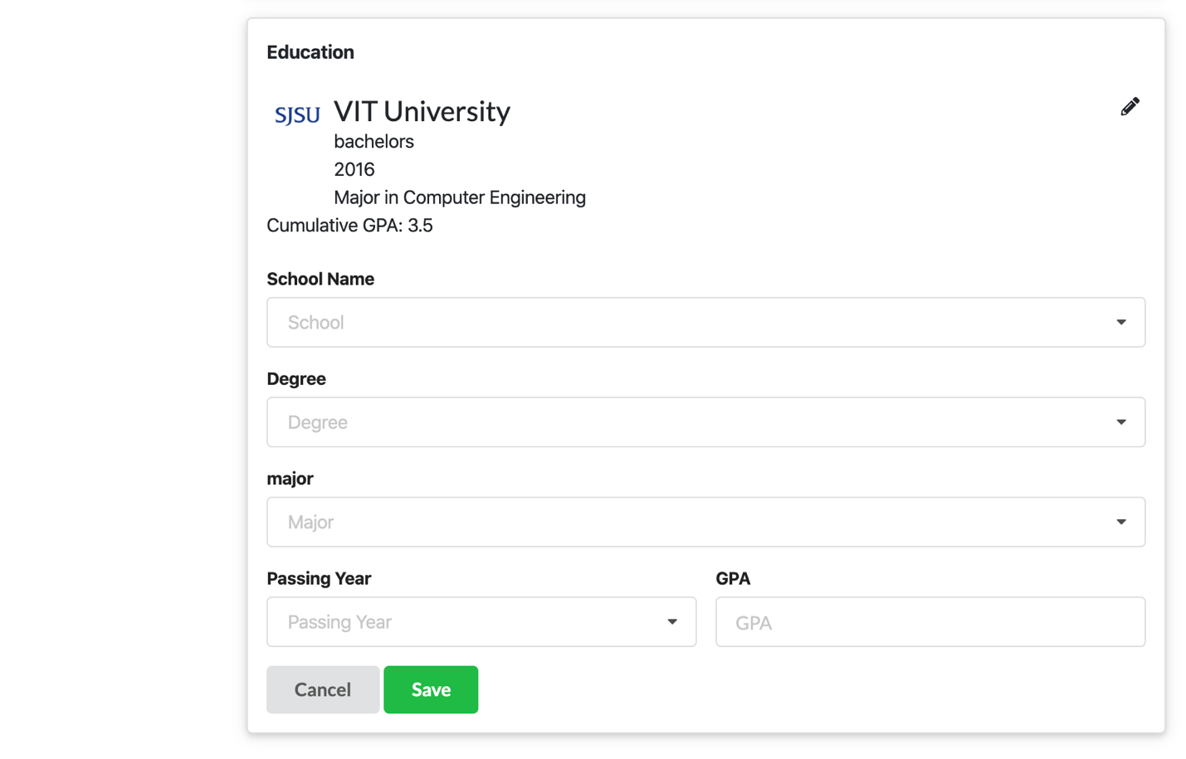

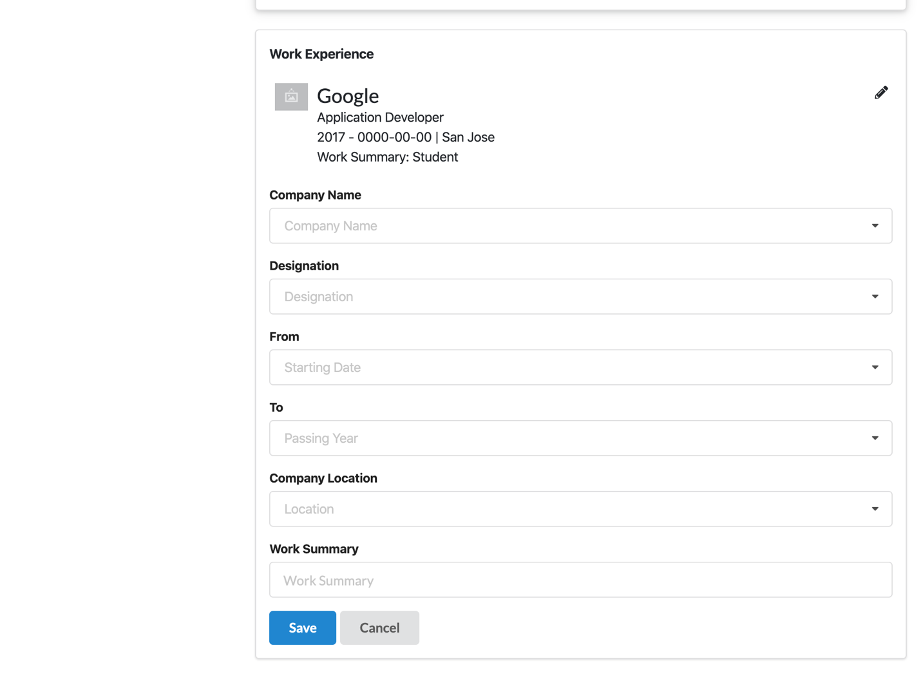

**Deployment:**

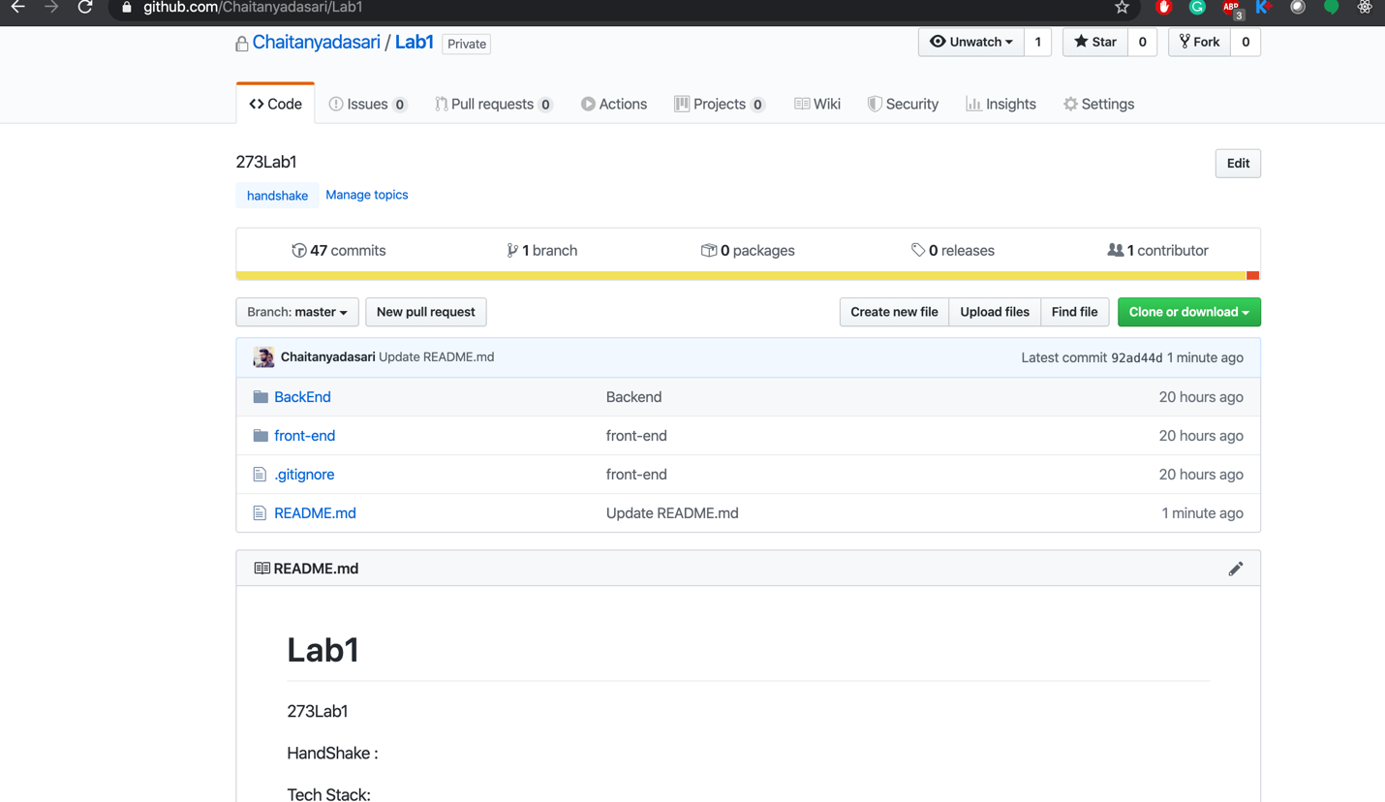

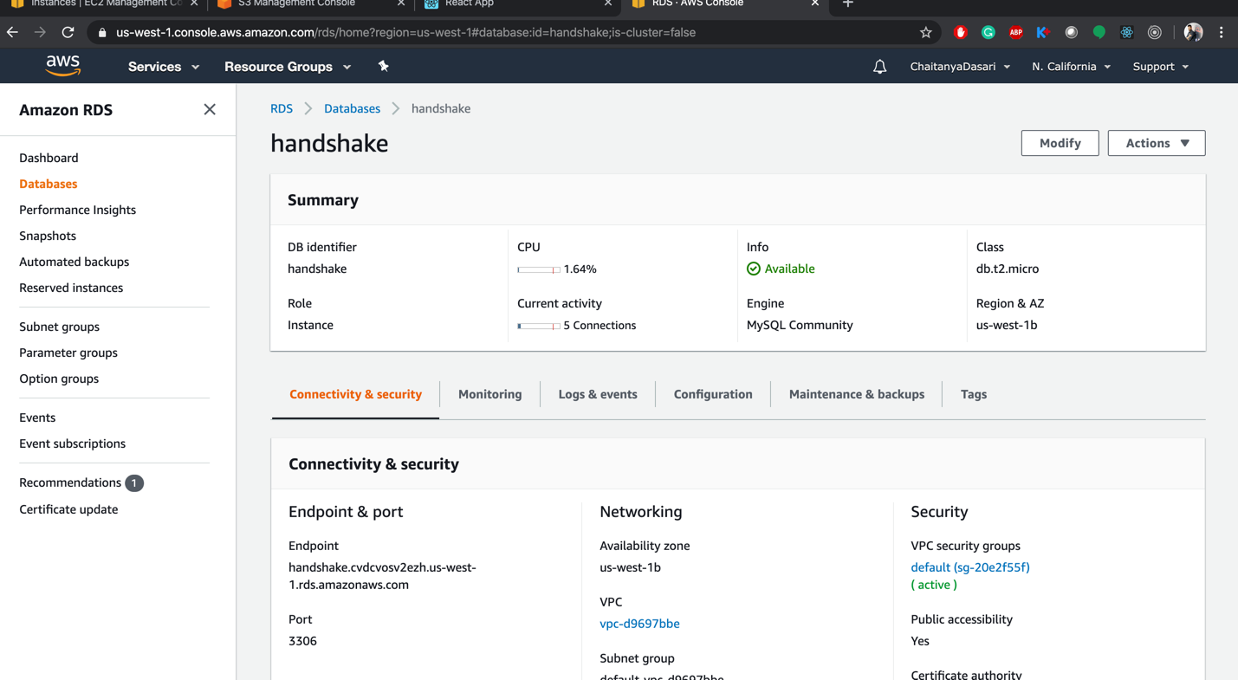

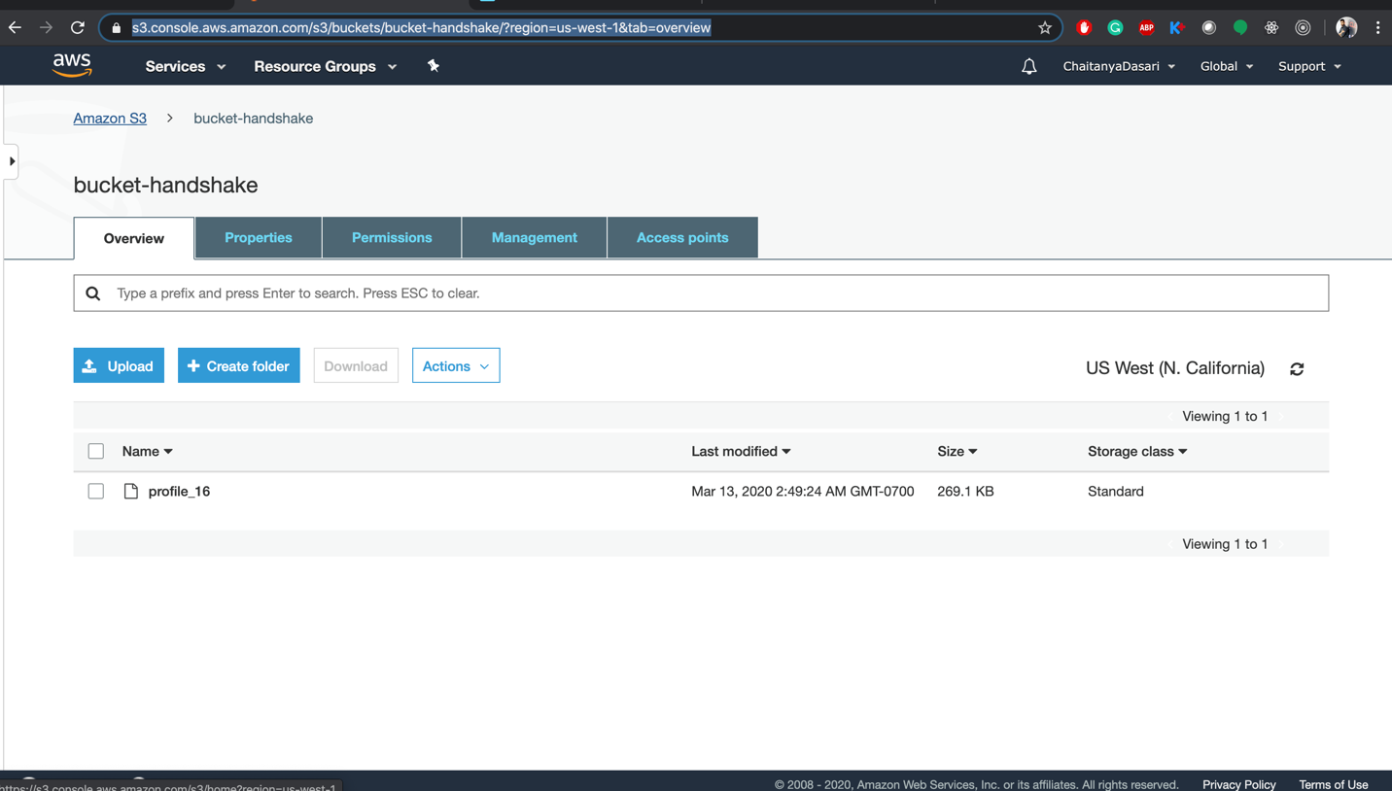

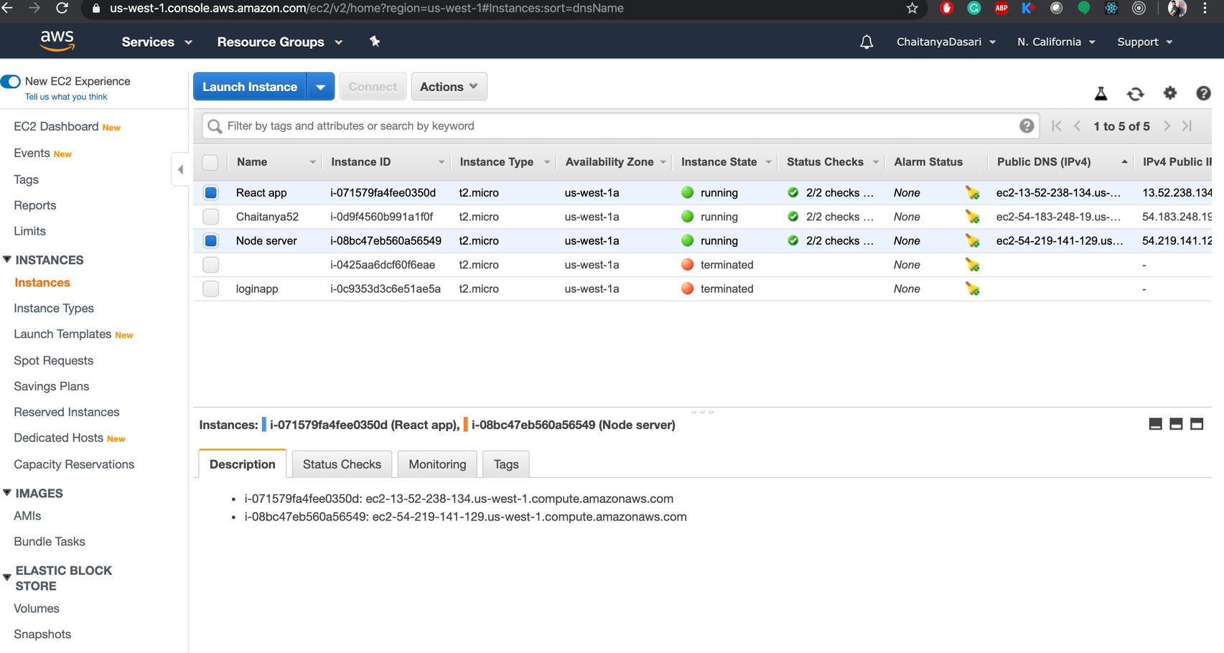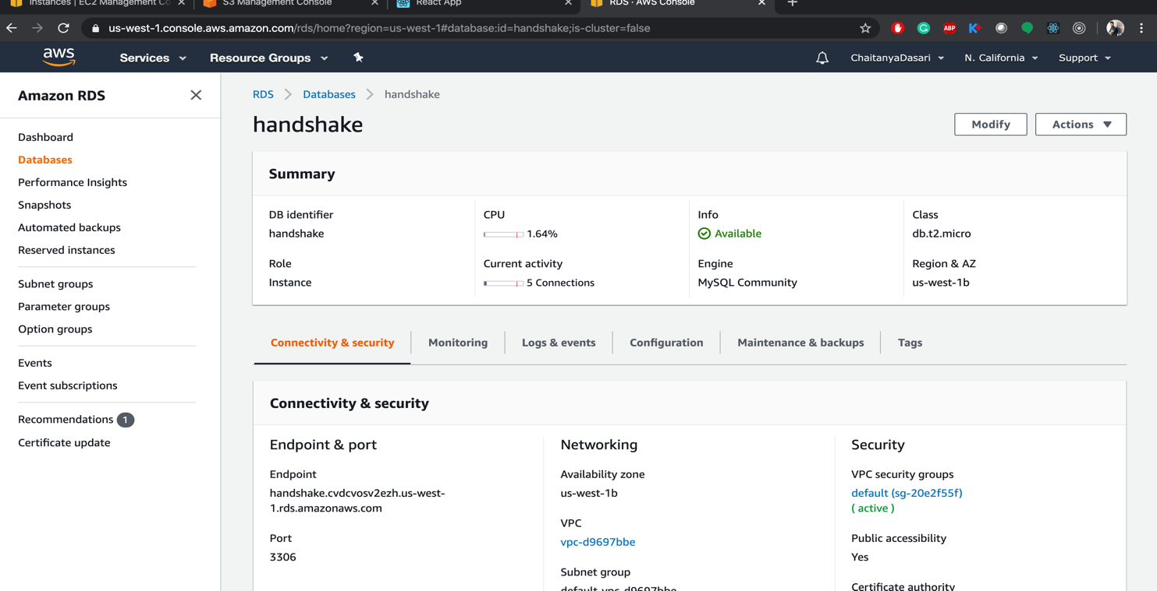

c)

Jmeter:

Used NewDriver:

Non Pooling:

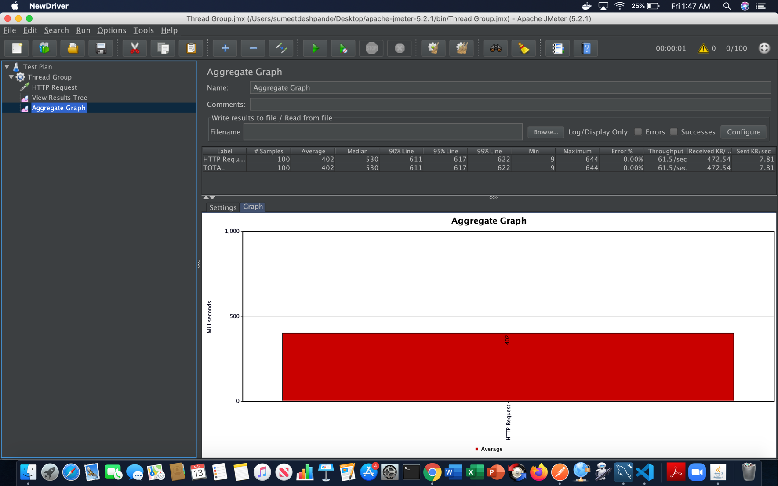

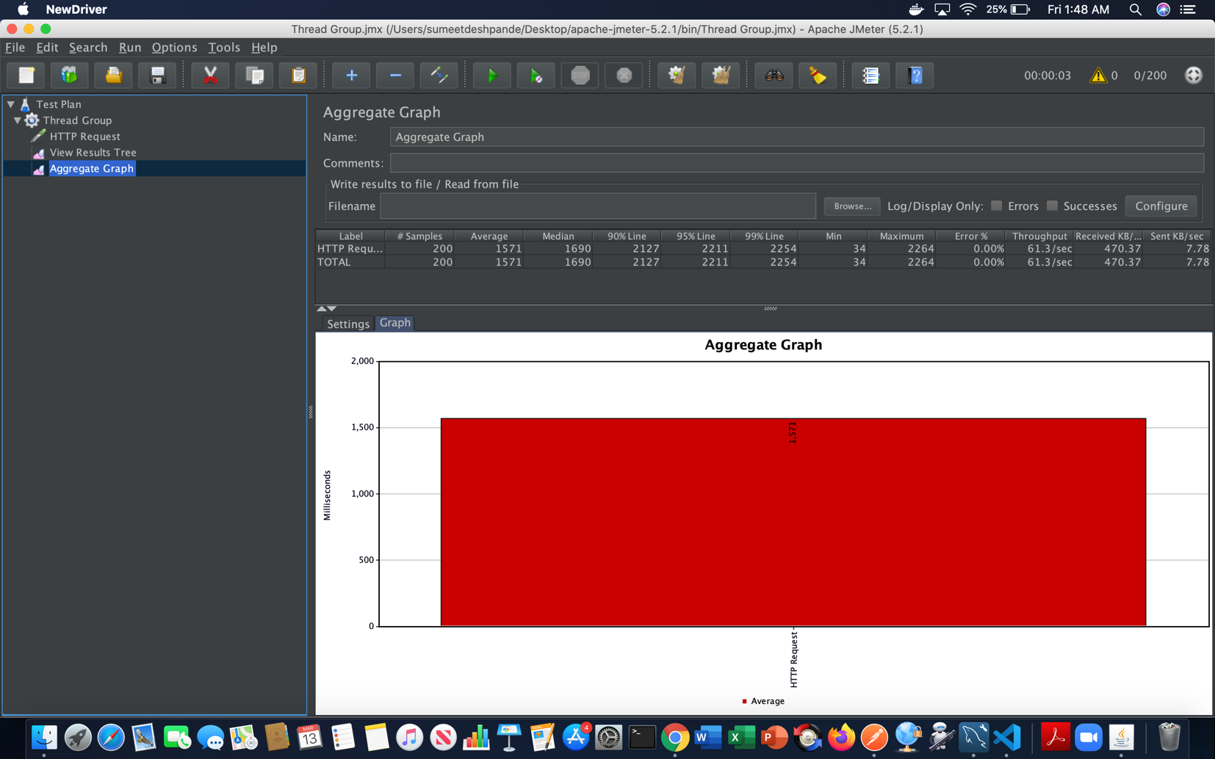

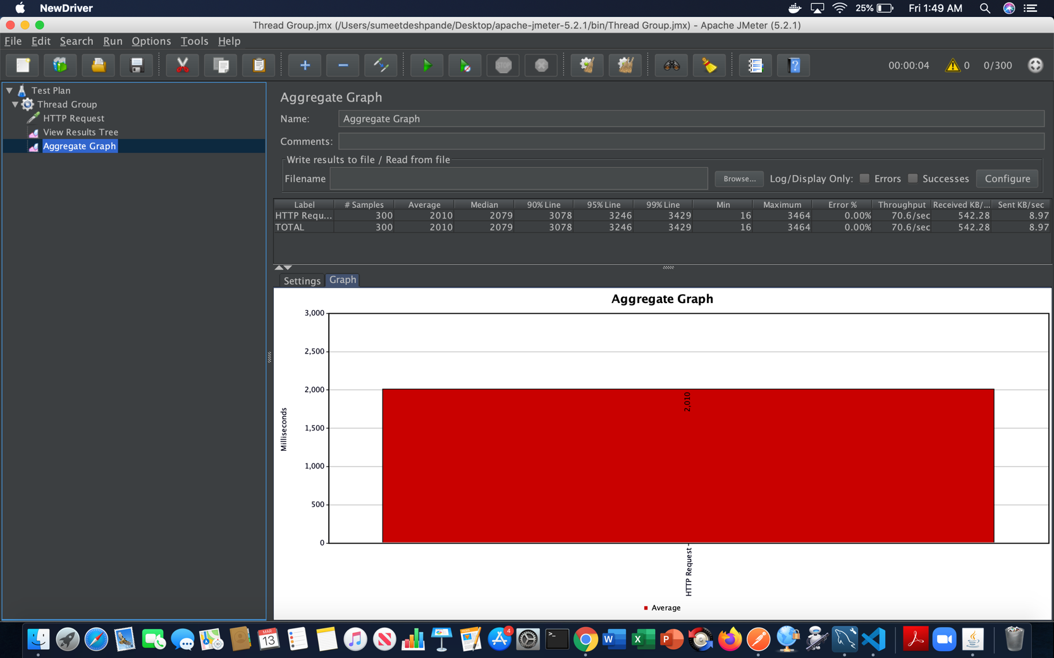

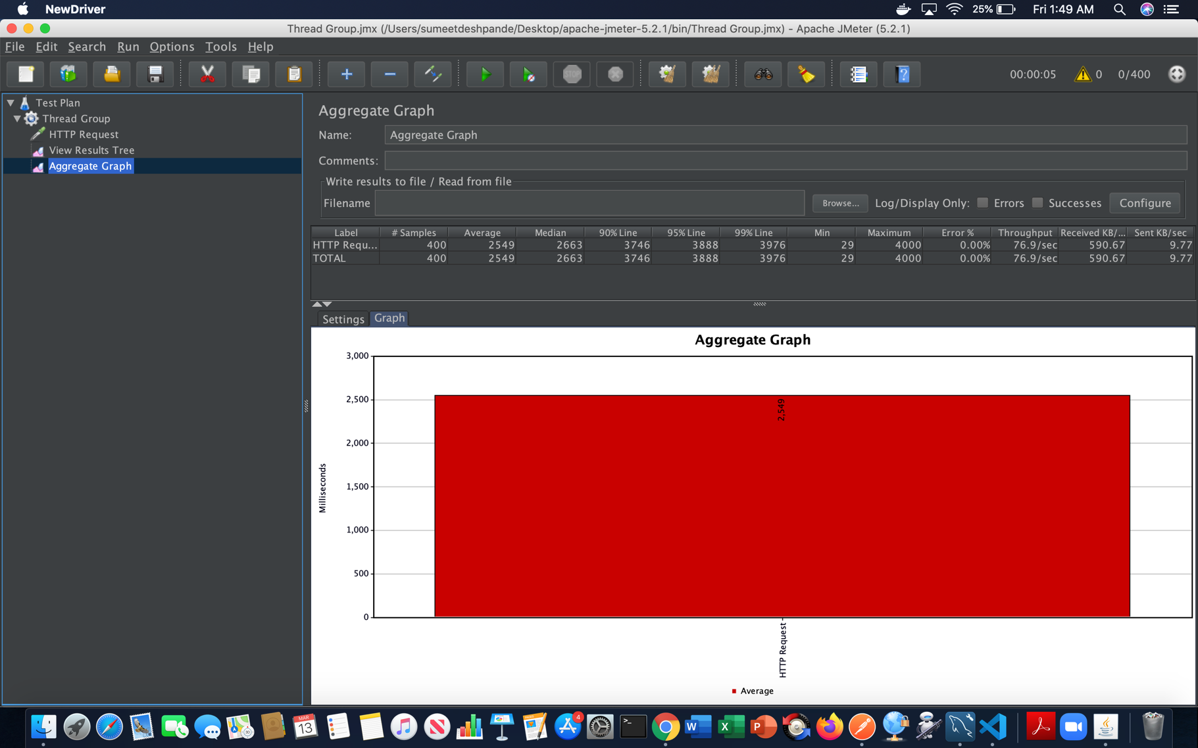

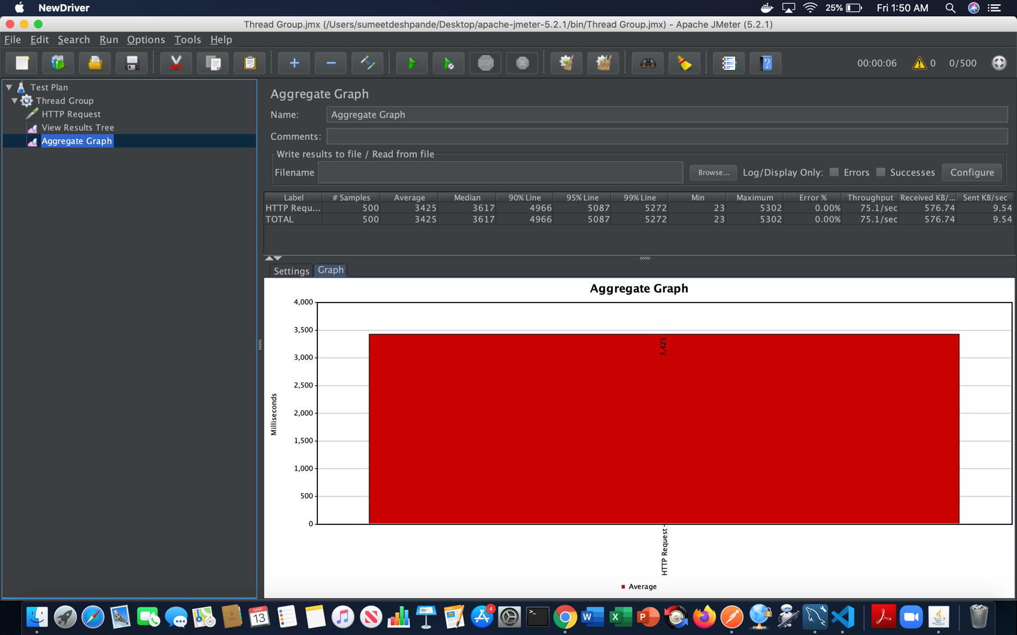

Pooling:

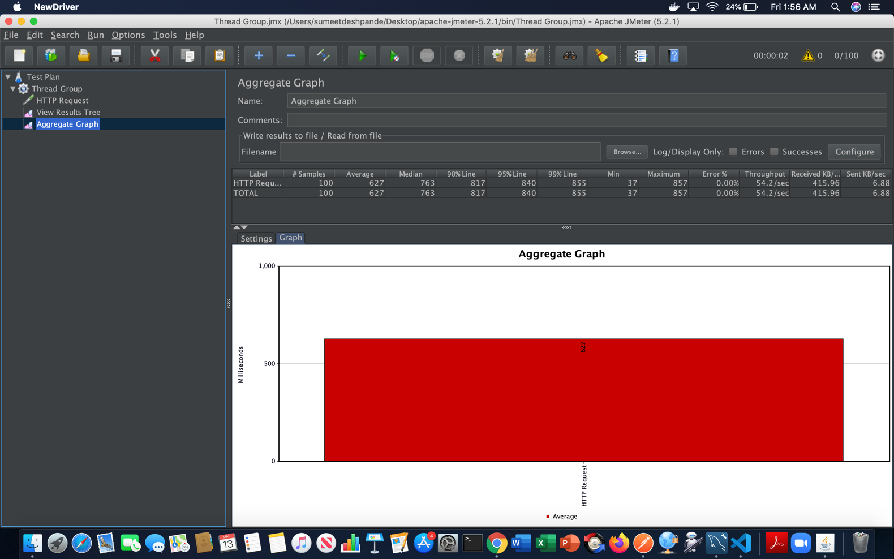

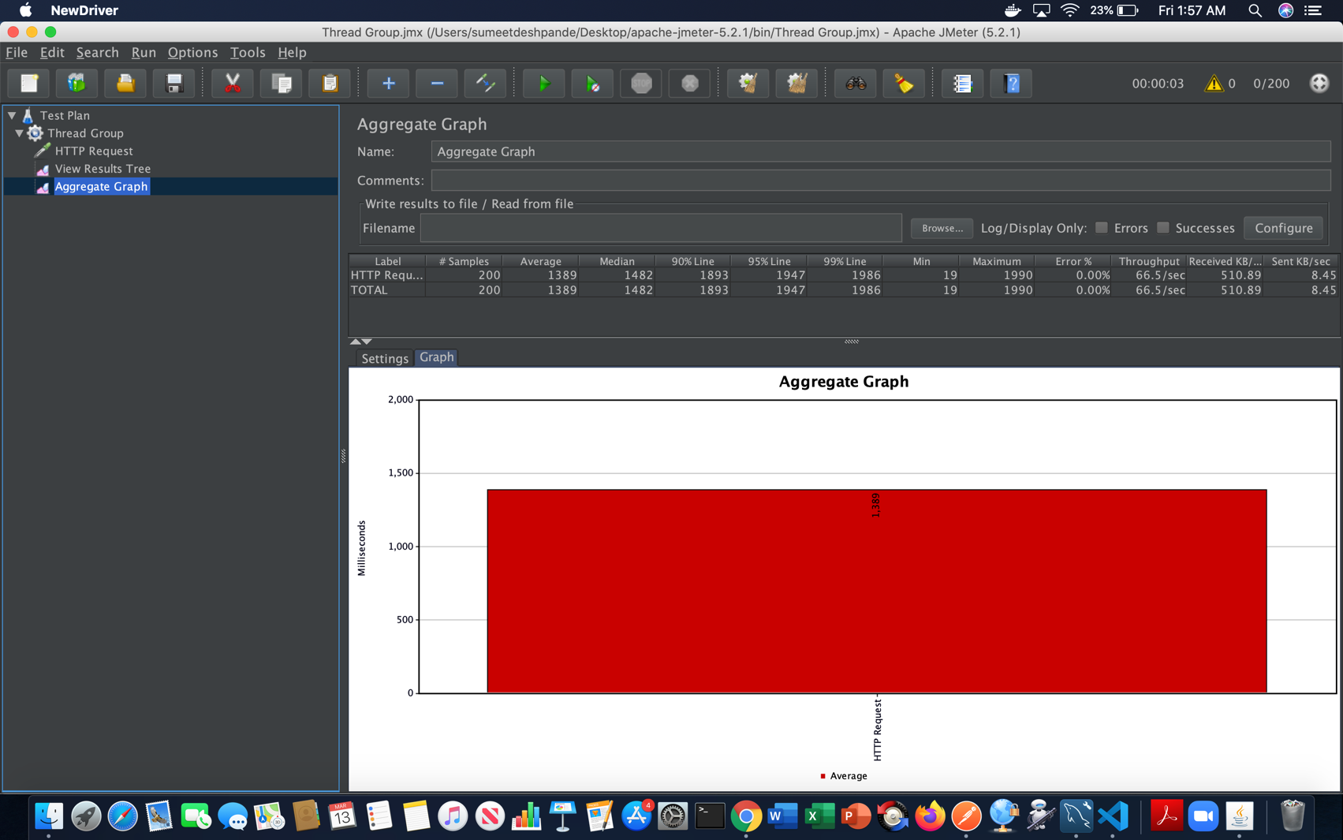

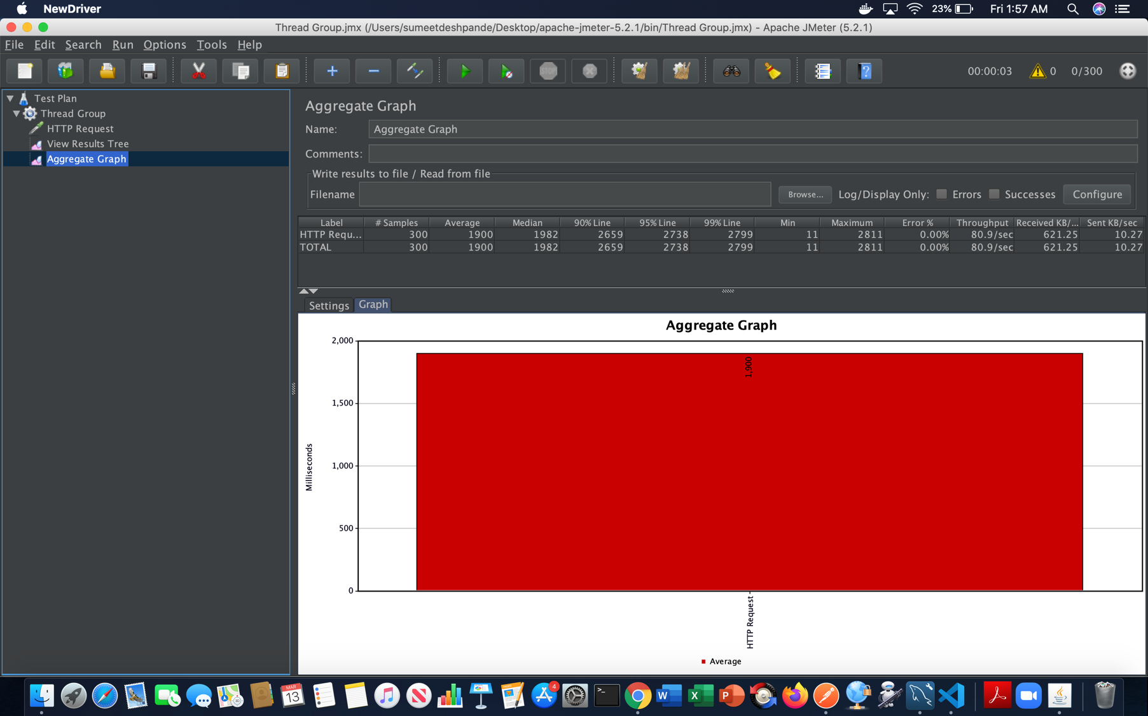

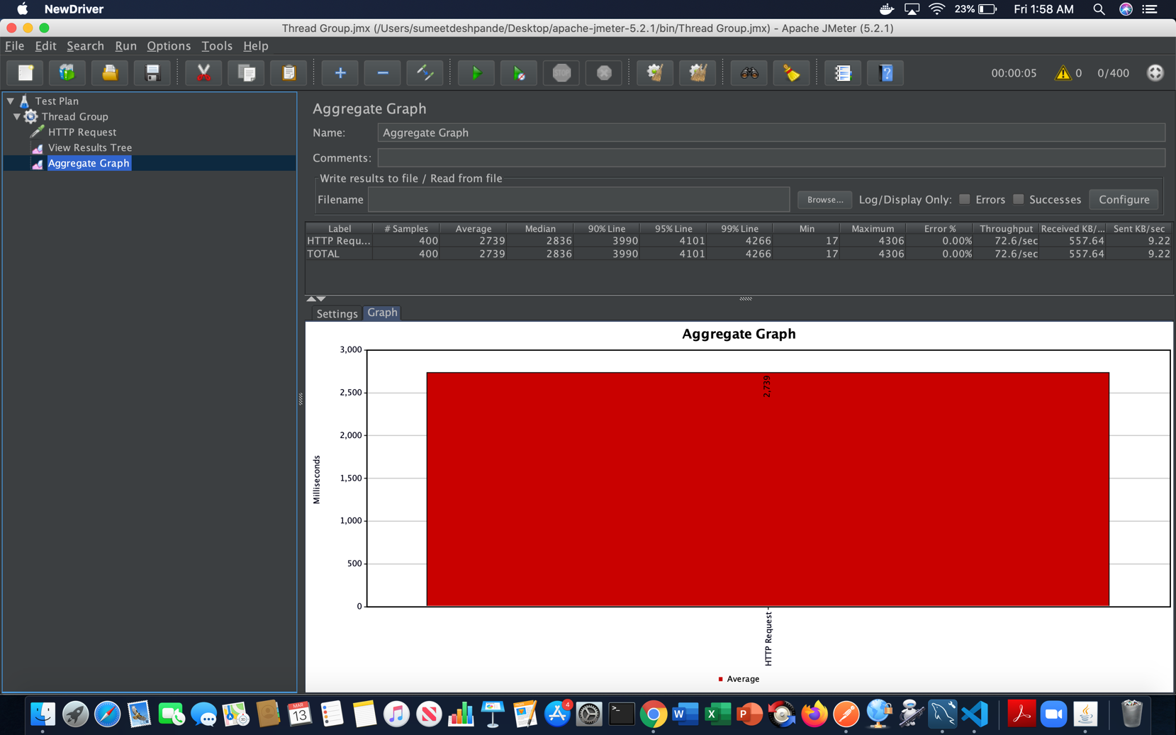

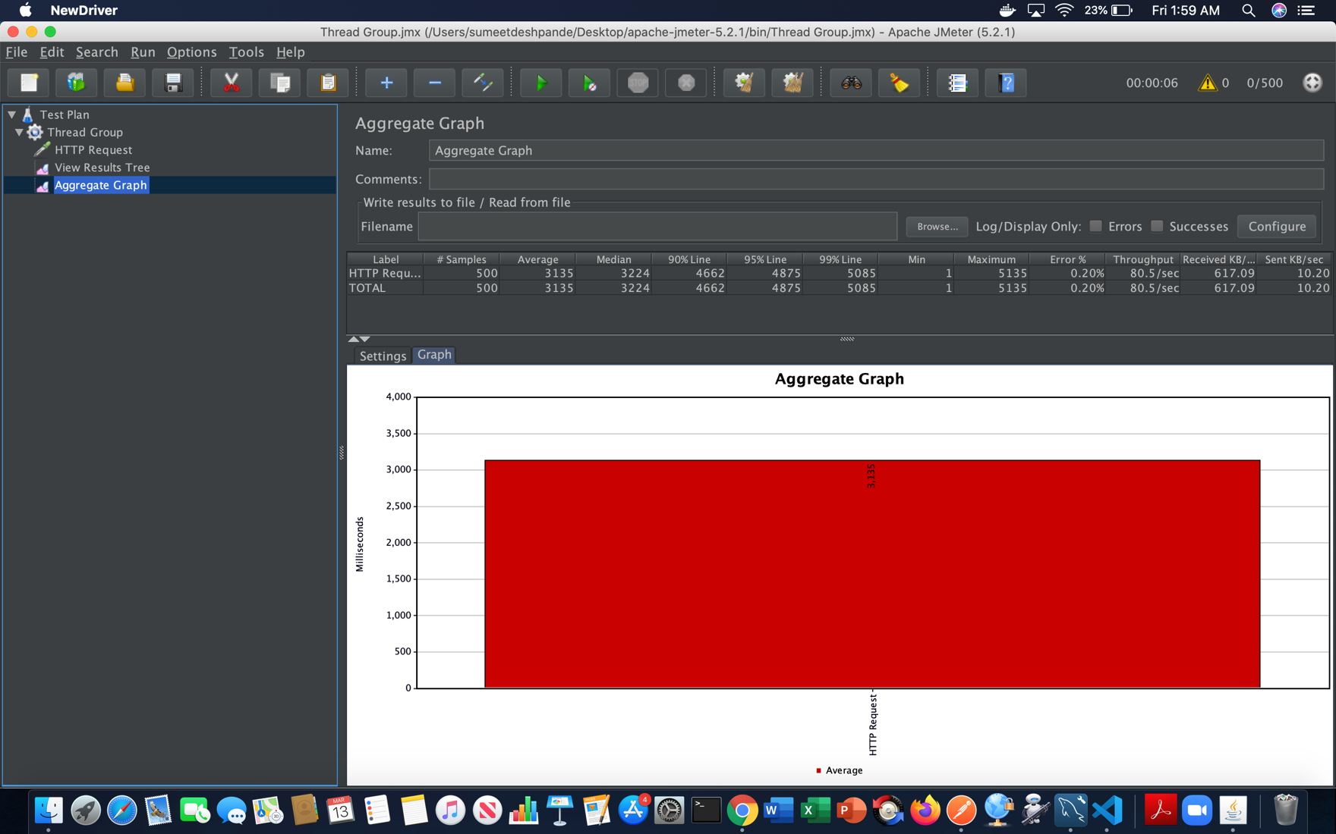

Performance is good ranging it from 70% to 82% which is decent, but we can increase this throughput. We used the JMeter and Mocha we can do horizontal scaling for the application to increase the throughput.

Big scale applications in real time do the same Jmeter as a metric for performance they also use Fiddler and other tools.

**Mocha Testing:**

Was able to pass 2 cases and one case failed and later completed it in the flow. Very helpful when you want to see the response of the api that you have written.

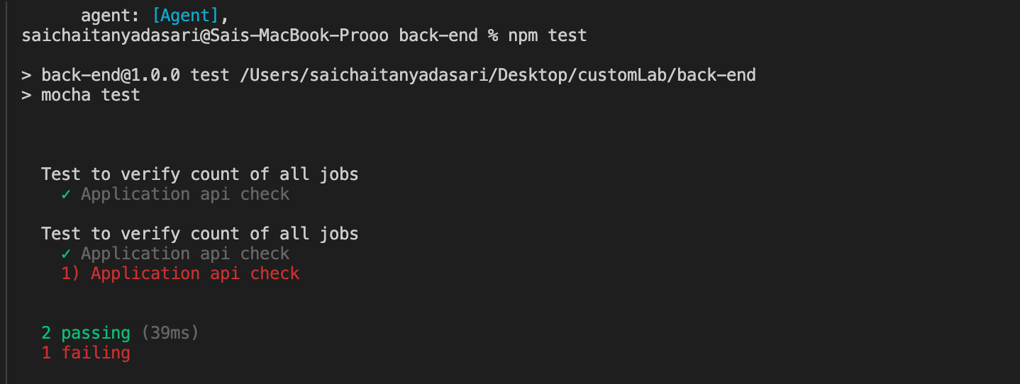

Video Demo Links:

Students Work Flow:

<https://drive.google.com/file/d/1OexA46pYkWrUvWyf_k3UmFPiuD0QWrf_/view>

Employer Flow:

<https://drive.google.com/file/d/1E9o9AYp5l2G9lhp3InT9FqGHfx9-lbAK/view>